20 Consulting Behavioral Interview Questions and Sample Answers
Meta description: WSG founder Stephen Turban walks through 20 consulting behavioral interview questions, with what each one tests and a full sample answer for every one.

The question I remember best from my McKinsey interviews wasn't a case. It was a follow-up. I'd prepared a story about a project I led in college, and I'd told it in mock interviews often enough that it ran a clean two minutes. The interviewer let me finish, then asked what I had actually said to the teammate who disagreed with me. Then what he said back. Then what I did next. We spent most of the behavioral portion on that one story, and by the end I understood something nobody had told me: consulting behavioral interview questions are scored on the specific actions you took, not on how the story ends.

I'm Stephen Turban. I went to Harvard, went through McKinsey's on-cycle recruiting, worked at McKinsey, and now run WallStreetGuide, where I coach undergrads through MBB, tier 2 and Big 4 strategy interviews. Every cycle I watch students who can run a profitability case cold lose offers on the behavioral half.

The 20 questions below are the ones that come up most, grouped by what the interviewer is scoring. Each one gets a full sample answer in a student's voice, with the kind of detail that survives a follow-up.

How many behavioral questions are in a consulting interview?
Expect one to three behavioral questions per interview and four to six interviews before an offer, so a full process can ask for a dozen stories, though you can reuse a story with an interviewer who hasn't heard it. At McKinsey, each interview opens with the Personal Experience Interview, which spends about ten minutes on a single story before the case starts. At BCG and Bain, behavioral questions sit at the start of a case interview or in a separate fit conversation, and partners in final rounds often ask two or three in a row. Eight well-prepared stories cover almost every question on this list, because interviewers reuse the same handful of themes under different wording.

How is the McKinsey PEI different from a normal behavioral interview?
The McKinsey PEI goes deep on one story for about ten minutes instead of skimming three or four, and every follow-up asks what you did, said, or decided. McKinsey's interviewing page asks candidates to prepare two personal examples that show their skills in the areas it assesses, and it names the three PEI themes as personal impact, entrepreneurial drive and inclusive leadership (the fourth area on that page, problem solving, is the case) [VERIFY: the PEI theme labels on mckinsey.com/careers/interviewing; some prep sites add a fourth theme, often called courageous change, that McKinsey's own page doesn't name]. A normal behavioral interview at a Big 4 firm might cover five questions in twenty minutes. The PEI covers one, and the interviewer will ask you what the other person said back. Prepare PEI stories with dialogue in them, because "what did you say next" is the question that separates a real story from a summary. Our guide to the McKinsey PEI covers the format in full.

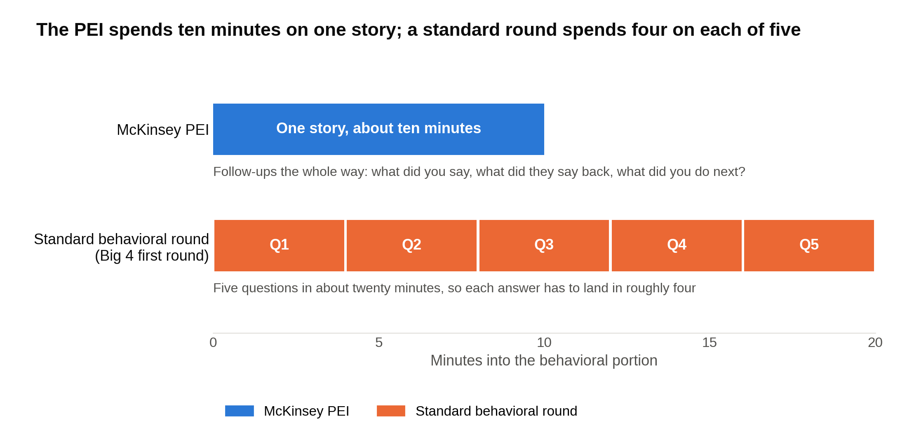
Same half hour of fit questions, two very different shapes: the PEI goes deep on one story and a standard round skims five.

What each firm is scoring in a consulting behavioral interview
Behavioral interviewing is younger than most students assume. An industrial psychologist named Tom Janz developed what he called the patterned behavior description interview in the late 1970s and published the first study on it in 1982. The idea was to ask candidates what they actually did in past situations instead of what they would do in made-up ones. Sixteen years later, Frank Schmidt and John Hunter reviewed 85 years of hiring research and found that structured interviews predicted job performance with a validity of 0.51, against 0.38 for unstructured ones. Validity here is the correlation between the interview score and how the person later performed on the job, where 1.0 would mean the interview predicted performance perfectly and 0 would mean it told you nothing. A jump from 0.38 to 0.51 is the difference between a weak signal and one worth building a hiring process around. Consulting firms use fixed dimensions and scoring sheets because structured conversations about past behavior predict performance far better than a free-form chat, so the "soft" half of the interview is graded as strictly as the case.

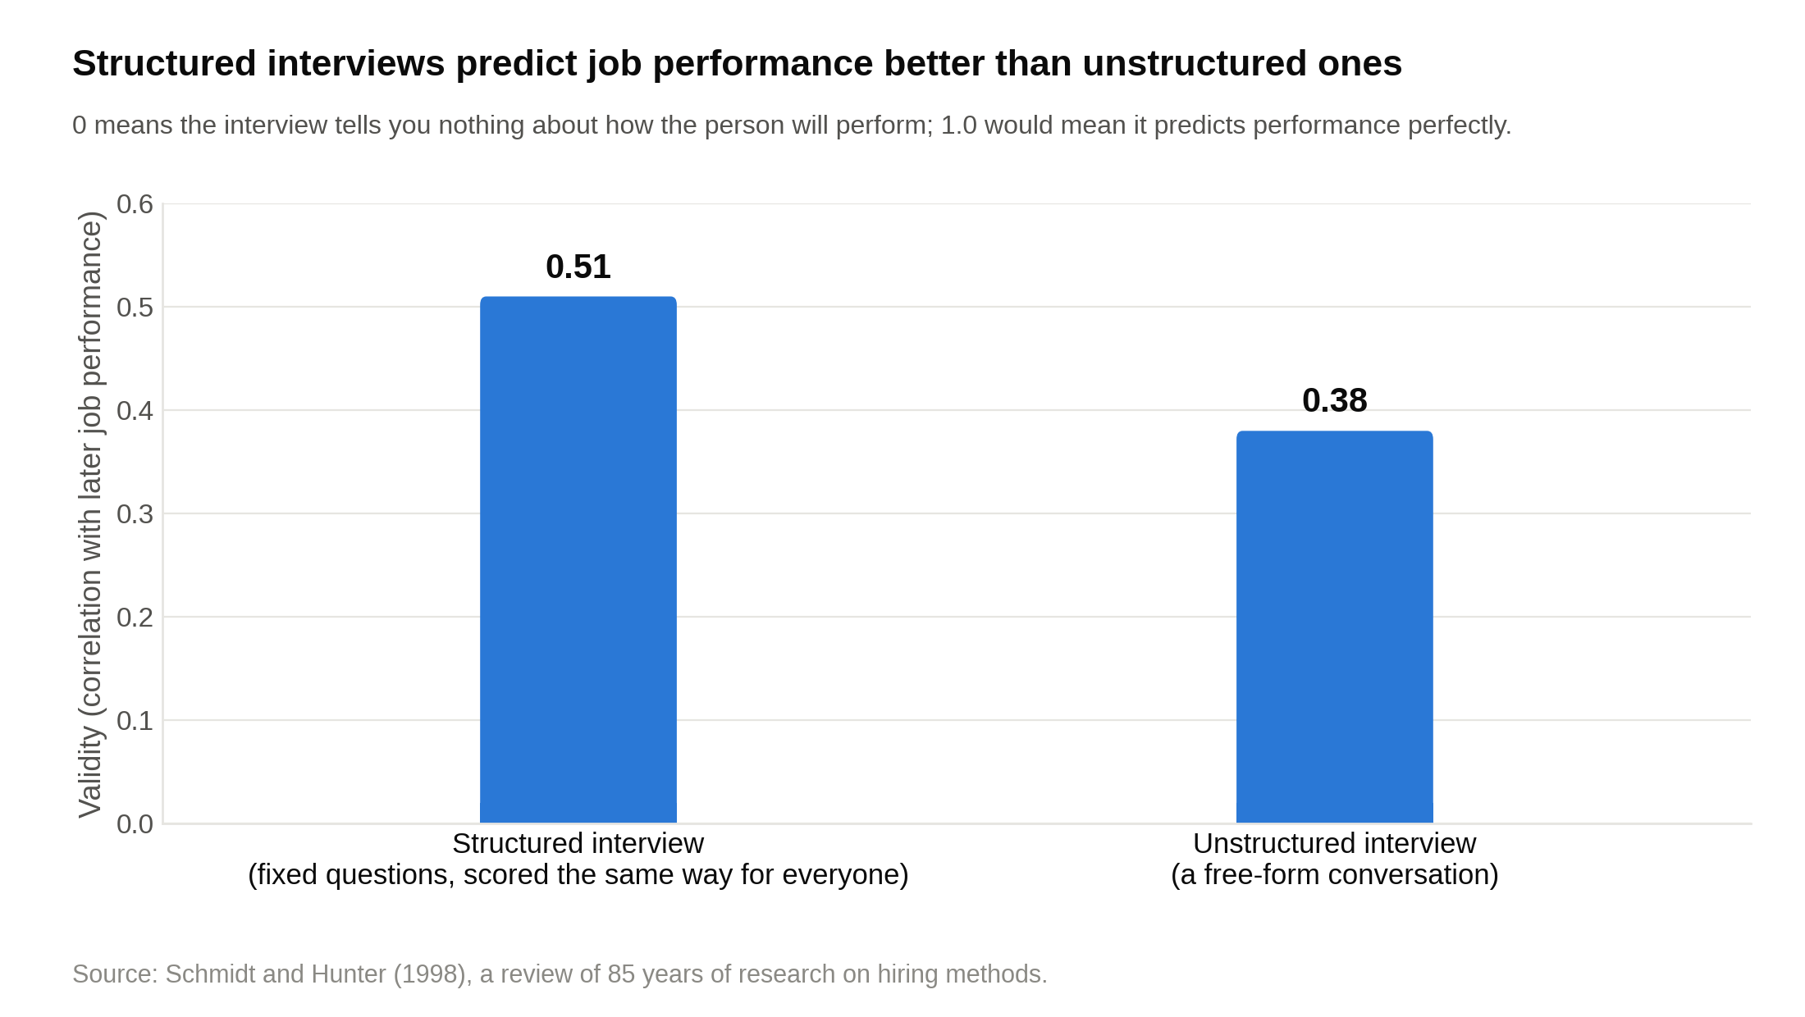
The jump from 0.38 to 0.51 is why the firms grade your stories against a sheet, per Schmidt and Hunter's 1998 review of 85 years of hiring research.

Each firm runs its own version.

McKinsey scores one story at a time against three named themes, and the follow-ups are the test. The three themes on McKinsey's interviewing page are personal impact, entrepreneurial drive and inclusive leadership, each with a sample question under it (for personal impact, the page's example is a situation where you worked with someone who held the opposite opinion). McKinsey's own advice on its interviewing page is to "focus on your specific role" and describe "the key actions that were critical to success," which is a polite way of saying the interviewer will keep asking what you, personally, did. Scale is part of why the scoring is so structured. McKinsey reportedly received about 800,000 applications for roughly 8,000 jobs in 2018 [VERIFY: figure and year; widely cited from press coverage of McKinsey's hiring], and a firm interviewing at that volume needs every interviewer grading the same way.

BCG asks behavioral questions in a shorter, more conversational format and grades them against five qualities it publishes. BCG's interview process page describes a "skills interview" that explores "your experience, skills, and motivation for joining BCG" as "your chance to go beyond your resume," and it lists integrity, intellectual curiosity, creative thinking, collaborative mindset and drive as what its consulting interviewers look for. In practice the behavioral questions arrive at the start of case interviews and again in the final round: two or three questions, two to three minutes each, with follow-ups when the interviewer senses a gap. A BCG alum quoted on the same page says the key is to "relate your answers back to the requirements of the job." That one sentence is the best single instruction for a BCG fit interview. Say what the story proves about how you'd work on a case team.

Bain is different again.

Bain weights team behavior and "why us" harder than the other two, and it tells you it's scoring you. Bain's hiring process page says interviews are "designed to highlight your strengths and show us how you think," that after each interview "you'll learn exactly how it went" based on "an objective scoring system," and that it wants people who'll thrive where "your colleagues will never let you fail." Its interviewing page asks candidates to "come ready to talk about our operating principles" and to "explain why they want to join us specifically." So two things carry extra weight at Bain: stories where you made a teammate better, and a "why Bain" answer with a name in it.

At tier 2 and Big 4 strategy firms, behavioral questions are shorter and more numerous, so the skill is landing a complete story in 90 seconds rather than surviving ten minutes of follow-ups. L.E.K.'s careers blog describes first rounds that mix "background and behavioral questions" into the case interviews, including personal questions an associate said were used "to test my storytelling ability." Deloitte's behavioral interview tips page names the STAR method outright (situation, task, action, result) and lists the question types it asks: juggling priorities, solving a problem on your own, managing team conflict, working with incomplete information, leading a project, and adapting to change. Oliver Wyman, Kearney, Strategy& and EY-Parthenon run the same mix in my experience coaching students through them: fit questions woven into case rounds, plus a partner conversation at the end that is mostly behavioral. The questions are the same 20 below. The time budget per answer is shorter.

How to build eight stories that cover all 20 questions
Every story you tell should trace to a line on your resume, because the interviewer is reading it while you talk and will ask about the gap if the two don't match. Before you read the questions, list the eight experiences below from your own life. Each one should have a number in it (people, dollars, hours, percentage points) and a moment where things went wrong before they went right.

Story | Questions it can answer
A team you led when it was failing | 1, 3, 12, 14
Something you built from nothing | 9, 11, 18
A person whose mind you changed | 5, 6, 7
A time you pushed back on someone senior | 8, 17
A failure that cost something real | 15, 16
Working across a real difference | 4, 13
A goal with a number attached | 9, 10
The project that made you want consulting | 18, 19, 20

Each story follows the same shape when you tell it:

- Two sentences of setup: where you were and what your role was.
- The problem, stated plainly, with what was at stake.
- Your actions, in the first person, with at least one line of what you actually said.
- The result, with a number.
- One sentence on what you'd do differently or what changed in how you work.

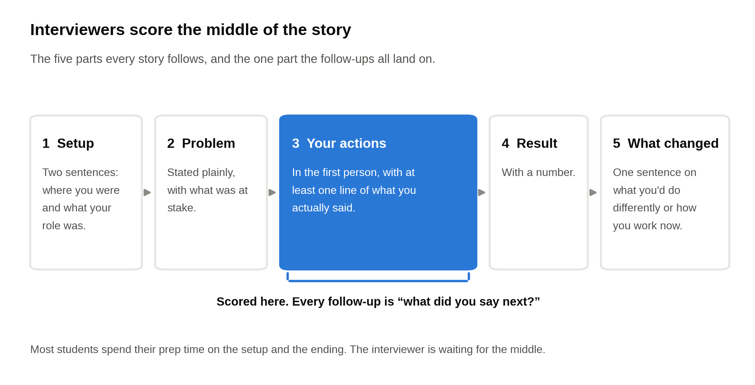
Every story has the same five parts, and the follow-ups all land in the third one, so write the actions out before you practice the rest.

Interviewers score the middle of the story, the actions, and most students spend their time on the setup and the ending. If your consulting resume has a bullet with a number on it, that bullet is a story waiting to be told.

Now the questions.

Consulting behavioral interview questions about leadership
1. Tell me about a time you led a team through a difficult project.

Leadership stories are scored on the moment the team was stuck and what you personally did to unstick it.

- What they're testing: whether you take responsibility for an outcome that depends on other people, and whether you understood why the team was struggling before you acted.
- What a strong answer includes: the size of the team, the specific obstacle, two or three actions that were yours alone, a measurable result, and one sentence on what you'd do differently.
- Where it shows up: the McKinsey PEI (leadership), BCG first and final rounds, Bain, and nearly every tier 2 and Big 4 fit interview.

Sample answer: "Junior year I was co-director of our campus consulting club's pro bono practice, and we took on a project for a regional food bank that wanted to cut the time between donation pickup and distribution. Four weeks in, the team of five had three different versions of the route analysis and no agreement on which data to trust. Two members had stopped showing up to meetings. I sat down with each of them separately and learned the real problem: one felt the analysis was over his head, and the other thought the client didn't want our help. I reassigned the data cleanup to the first person with a clear template so he could contribute without the Excel modeling, and I set up a call with the food bank's operations manager so the second person could hear directly what she needed. Then I cut our scope from six recommendations to two. We delivered a route consolidation that reduced the pickup-to-shelf time from an average of 52 hours to 31, and the food bank adopted it that fall. The thing I'd change: I waited four weeks to have those one-on-one conversations. Now I have them in week one."

Pick a leadership story where the team was failing before you acted. A team that was already working doesn't prove you can lead.

2. Tell me about a time you led people who didn't report to you.

Leading without authority is the first-year consultant's daily reality, and this question simulates it.

- What they're testing: influence without a title, and whether you build buy-in or just assign tasks.
- What a strong answer includes: who the people were and why they had no reason to listen to you, how you earned the right to coordinate them, the mechanism (a shared goal, a clear plan, taking the worst job yourself), and the result.
- Where it shows up: Bain and BCG final rounds especially, and the McKinsey PEI as a leadership or impact story.

Sample answer: "I was a sophomore on the planning committee for our school's spring case competition, responsible for recruiting judges and the 20 student volunteers who ran the day. None of them reported to me, most were older, and two weeks out, half hadn't confirmed. Instead of sending another mass email, I called the eight most reliable people and asked each to own one block of the day and recruit two friends for it. I wrote a one-page run of show so nobody had to guess where to be. And I took the 6 a.m. setup shift myself, which people noticed. On the day, 22 volunteers showed up, the schedule ran within ten minutes of plan, and the judges' feedback forms rated organization 4.7 out of 5, up from 3.9 the year before. What I learned is that people with no reason to listen to you will follow a plan that's clear and a person who's visibly doing the hardest job. I've used the same approach on every group project since: give people a piece they own, write the plan down, take the worst shift."

When you had no authority, say exactly what gave people a reason to follow you. "I motivated the team" explains nothing.

3. Tell me about a time you made an unpopular decision.

Unpopular-decision stories test whether you can hold a position under social pressure and still keep the team with you.

- What they're testing: judgment, backbone, and how you treated the people who disagreed.
- What a strong answer includes: the decision, who opposed it and why their objection was reasonable, how you decided, how you communicated it, and what happened afterward, including anything you got wrong.
- Where it shows up: the McKinsey PEI (personal impact or inclusive leadership), Bain final rounds, and partner interviews everywhere.

Sample answer: "As treasurer of our 60-member investment club, I recommended cutting the annual New York trek from three days to one after I found we'd spent $4,200 of a $9,000 budget on the previous year's trip for 14 students. The board hated it. The trek was the club's most popular event, and the two seniors who ran it argued, fairly, that it was how members got internship contacts. I didn't overrule them on the spot. I pulled the numbers on who had attended (mostly juniors and seniors who already had offers) and proposed we redirect $2,500 into a speaker series that reached all 60 members and a one-day trek capped at 10 sophomores. The vote was 5 to 4 in favor, which is not a mandate. I asked the two seniors to run the one-day version so it stayed theirs. Attendance at the speaker series averaged 38 across six events, and the sophomore trek produced three summer internships that members told us came from those meetings. Two board members still think I was wrong, and I understand why. The numbers were on my side from the start. Getting the two seniors back on my side took another semester."

Name who disagreed with your decision and why they had a point, because an unpopular decision with no reasonable opposition isn't a story about judgment.

4. Tell me about a time you helped someone on your team improve.

Developing other people is scored because consulting is an apprenticeship, and second-year analysts coach the first-years.

- What they're testing: patience, your diagnosis of what was holding the person back, and whether you made them better rather than doing their work.
- What a strong answer includes: a specific person, the specific gap, what you did and what you deliberately didn't do, and how they changed.
- Where it shows up: the McKinsey PEI (inclusive leadership), BCG, Bain (where team culture is the screen), and most Big 4 fit interviews.

Sample answer: "I was a teaching assistant for intro statistics, and one student in my section, a sophomore, failed the first midterm with a 48 while clearly working hard. In office hours I noticed she could set up every problem correctly and lost points in the arithmetic, usually because she tried to do everything in her head to save time. The fix wasn't more content. I asked her to write every intermediate step for two weeks, even the ones that felt childish, and we did one problem set together where I only asked questions and never touched her paper. That last part was deliberate. The week before, I'd caught myself solving a problem for a different student and realized he'd learned nothing. She scored a 79 on the second midterm and an 86 on the final, and she asked to be a TA for the course the following year. What I learned about coaching is that the person usually knows more than the score shows, and the job is finding the one habit that's hiding it."

A strong coaching story names the one habit you diagnosed, because "I mentored her" tells the interviewer nothing about how you think.

Consulting behavioral interview questions about impact and persuasion
5. Tell me about a time you changed someone's mind.

Changing a mind is scored on how well you understood the other person, never on how hard you argued.

- What they're testing: whether you diagnose why someone disagrees before you push, and whether you can persist without becoming a pest.
- What a strong answer includes: who the person was, what they believed and why it made sense from their seat, what you learned by asking, what you changed in your approach, and what they said once they shifted.
- Where it shows up: the McKinsey PEI (personal impact) above all, plus BCG and Bain fit rounds.

Sample answer: "The summer after freshman year I worked at a 30-person landscaping company near home, and the owner refused to move crew scheduling off paper. I'd pitched a free scheduling app twice and gotten nowhere. The third time, instead of pitching, I asked him why, and the answer wasn't about technology. He'd lost a week of jobs a few years earlier when a software subscription lapsed without warning, and he didn't trust anything he couldn't hold. So I stopped arguing for the app and offered a two-week trial where I'd keep the paper system running alongside it, so nothing could be lost. I also showed him the one number he cared about: crews were arriving at the wrong site about twice a week, and each misroute cost roughly $600 in wasted drive time. After the trial he moved scheduling to the app, kept a printed copy on the office wall, and misroutes dropped to one for the whole month of August. He still prints the schedule every morning. I learned to find out what the no is protecting before trying to change it."

Say what the other person's objection was protecting. Without that diagnosis, a persuasion story sounds like you wore someone down.

6. Tell me about a time you worked with someone who held the opposite opinion.

McKinsey asks this one almost word for word, and the score depends on whether you kept working with the person afterward.

- What they're testing: how you handle disagreement with a peer you can't avoid, and whether you find the shared goal underneath the argument.
- What a strong answer includes: both positions stated fairly, the moment it got hard, the specific thing you did to move forward, and the outcome for the work and for the relationship.
- Where it shows up: McKinsey's interviewing page uses a version of this as a PEI sample question, and Bain's team-fit screen and BCG's collaborative-mindset scoring both reach for it.

Sample answer: "My co-president and I ran a 25-person volunteer tutoring program at a middle school, and we disagreed about whether to expand to a second school. She saw demand: the second school's principal had asked twice. I saw that our tutor show-up rate had slipped to about 70 percent and thought we'd be promising something we couldn't deliver. We argued about it for three weeks and the rest of the board started avoiding the topic. What broke it was a conversation where I asked her what she was worried would happen if we said no, and she said the principal would stop trusting student groups entirely. That was a real cost I hadn't weighed. We agreed on a test: fix the show-up rate first, with a text reminder system and a two-strike policy, and expand the moment it held above 90 percent for a month. It took seven weeks. We opened at the second school in February with 12 tutors, and show-up rate that spring was 93 percent across both sites. She and I still disagree about how fast to grow things. We work well together anyway, and I think that's the point."

State the other person's position well enough that they'd agree with your summary, because interviewers hear a strawman as a sign you never really listened.

7. Tell me about a time you persuaded a group to change direction.

Persuading a group is a different skill from persuading one person, because a room has factions and you have to find the argument that works for most of it.

- What they're testing: reading a room, sequencing (who you talk to first), and how you handle the loudest objector.
- What a strong answer includes: the group and how it was split, the work you did before the meeting, how the meeting itself went, and the result.
- Where it shows up: Bain partner rounds, BCG final rounds, and the McKinsey PEI as a personal impact story.

Sample answer: "Our 40-person a cappella group voted every year on whether to do a paid winter tour, and for three years the vote failed because the seniors didn't want to give up winter break. As the junior business manager, I thought the tour was the only way to fund new arrangements, which cost about $400 each. Instead of making the case in the meeting, I spent the week before it. I talked to the five seniors individually and learned the real objection was a 10-day schedule, not the tour itself. I talked to the three most respected members and asked them to speak first if they agreed with the plan. Then I proposed a four-day tour with two paid shows at $1,500 each, which covered seven arrangements, and a hard rule that it ended by December 20. The vote passed 31 to 9. We ran the tour, netted $2,800 after travel, and the group has done it every year since. The lesson I took is that the meeting is where a decision gets ratified. The persuading happens before anyone sits down."

Interviewers know group persuasion happens before the meeting, so describe those conversations, not the vote.

8. Tell me about a time you influenced someone senior to you.

Managing up is scored on how you earned the right to push, which usually means doing the work before offering the opinion.

- What they're testing: whether you'll speak up to a partner or a client when you have a point, and whether you do it with evidence and without making them look bad.
- What a strong answer includes: the senior person and the stakes for you, the evidence you brought, how you framed it (a question, an option, a risk), what they decided, and whether you turned out to be right.
- Where it shows up: the McKinsey PEI (entrepreneurial drive), BCG, Bain, and the Big 4 "working with incomplete information" questions.

Sample answer: "As a summer intern at a 200-person regional insurance company, I was asked to build a model of customer churn by region, meaning how many customers cancel each year, and the director who assigned it wanted to rank regions by churn rate and cut marketing spend in the worst three. The model showed something else. The three worst regions by rate were also the three smallest, together under 4 percent of customers, while one large region had a middling rate but accounted for 31 percent of all lost customers. I was nervous about telling a director he was looking at the wrong number. So I didn't tell him he was wrong. I put both views on one page, rate and absolute count side by side, and asked whether the goal was to improve the ratio or to keep the most customers. He changed the plan to focus on the large region and kept a small test in one of the three he'd originally picked. I don't know yet whether churn fell, because the campaign started after I left. What I learned was to bring the alternative as a question with the numbers attached, which makes it easy for a senior person to change course without losing face."

Frame the pushback the way you actually did it in the room, because interviewers want to hear the wording that let a senior person change course gracefully.

Drive and achievement questions
9. Tell me about a time you set an ambitious goal and achieved it.

Drive stories work when the gap between start and finish is measurable and the odds were visibly against you.

- What they're testing: whether you set your own bar or wait for one, and whether you sustain effort over months rather than days.
- What a strong answer includes: the starting number, the target and why it looked unreasonable, a plan with two or three specific steps, the setback in the middle, and the ending number.
- Where it shows up: the McKinsey PEI (entrepreneurial drive), BCG's drive dimension, Bain, and L.E.K.

Sample answer: "When I became president of our campus data science club, it had 14 active members and had lost its department funding because attendance at events averaged nine people. I set a target of 60 active members and funding restored by spring, and the outgoing president told me that was unrealistic for a club that had never passed 25. The plan had three parts. I replaced general meetings with a six-week beginner Python series, since our survey showed people wanted a skill, not a community. I asked two professors to let me pitch the series for five minutes in their intro classes, which put me in front of about 300 students. And I partnered with the career center on a resume review night with alumni, which filled in two days. By March we had 71 members who'd attended at least three events, average attendance was 34, and the department restored $1,800 in funding plus a dedicated room. The hardest part was week three of the Python series, when attendance dropped to 19 and I almost cancelled it. We finished the series with 28, and most of them are the members who run the club now."

A drive story without numbers is a story about having a goal, not about hitting one. Give the start, the target, and the finish.

10. Tell me about a time you had to achieve something outside your comfort zone under time pressure.

Comfort-zone stories are scored on how fast you learned, not on how brave you felt, and McKinsey's own sample PEI questions include a version of this one.

- What they're testing: how you behave when you're not the expert and the clock is running, and whether you're resourceful about closing a gap.
- What a strong answer includes: why it was outside your comfort zone (a specific skill gap), the deadline, how you closed the gap (who you asked, what you learned, what you decided to skip), and the result.
- Where it shows up: the McKinsey PEI (entrepreneurial drive), Bain, and tier 2 firms, where a first-year is often handed a workstream nobody has taught them.

Sample answer: "Two weeks before our student-run venture fund made its first investment, our finance lead left for a semester abroad, and I was asked to build the valuation and present it to the fund's advisory board of four alumni. I'd taken one accounting class. I had never built a model. I spent the first two days learning what I didn't know: I asked the finance lead for a 30-minute call and his old model, and I read the company's cap table, the record of who owned what share of it, until I understood every row. I decided to skip a full discounted cash flow model, the kind that forecasts years of cash and discounts it back to today, because I couldn't have defended one under questioning. Instead I priced the company against six similar seed-stage software companies, using what investors had paid for those, with a clear note on why I'd chosen that method. The night before, I did a practice presentation for two club members and cut three slides they found confusing. The board approved a $25,000 investment at the valuation I proposed, and one advisor asked whether I'd considered finance as a career, which is part of why I'm here. I'd never say I was comfortable. I'd say I figured out which parts I had to get right and which I could leave out."

Say what you chose to skip and why, because knowing what to leave out under a deadline is the skill the interviewer is listening for.

11. Tell me about a time you started something from nothing.

Starting something is the purest entrepreneurial-drive story, and interviewers score it on what you did in the first two weeks, when nobody cared yet.

- What they're testing: initiative without permission, tolerance for ambiguity, and follow-through after the novelty wore off.
- What a strong answer includes: the gap you noticed, the first concrete action, the point where it almost died, the scale it reached, and what exists now without you.
- Where it shows up: the McKinsey PEI (entrepreneurial drive), BCG (drive and creative thinking), and Bain.

Sample answer: "Sophomore fall I noticed that first-generation students at my school had no organized way to find upperclassmen in their intended major, so I started one. The first two weeks were unglamorous. I emailed 40 juniors and seniors asking them to mentor, and six said yes. I set up an online sign-up form for mentees, got 11 responses, matched them by major by hand, and sent each pair a one-page guide with three suggested first conversations. The program nearly died in November when half the pairs stopped meeting. I called the mentees and found the problem was that nobody knew whose job it was to schedule, so I set a rule that mentors book the first three meetings, and I sent the calendar nudges myself. By spring we had 34 pairs, 80 percent of which met at least four times, and the dean of students' office agreed to fund $500 in coffee vouchers and host the fall kickoff. It now runs with a committee of five, and I'm no longer needed day to day, which was the goal from the start."

The moment the thing you started almost failed is the part to tell, since surviving it is what separates building something from announcing it.

Teamwork and conflict questions
12. Tell me about a conflict on a team and how you resolved it.

Conflict stories are scored on the diagnosis, so explain why the disagreement existed before you explain how you fixed it.

- What they're testing: whether you treat conflict as information or as something to suppress, and whether you're fair to the other side when you retell it.
- What a strong answer includes: the two positions, the underlying cause (different information, different incentives, or different definitions of done), what you did, and the outcome for the work and the relationship.
- Where it shows up: every firm. Bain weights team fit hardest, and Deloitte lists "managing team conflicts" among its standard behavioral questions.

Sample answer: "On a four-person case competition team, two of us wanted to recommend the client exit a product line and two wanted to double down, and by the night before the final we were barely speaking. I was on the exit side. Around midnight I realized we weren't actually arguing about the recommendation. The other two had done the customer interviews and we had done the financials, and each pair trusted its own data. So I asked them to walk me through the three interviews that most convinced them, and I walked them through the margin math line by line. Both sides were right: the product lost money at current prices, and customers loved it. That gave us the real recommendation, which was to keep the product and raise price 15 percent, with a six-month kill criterion if volume fell more than 20 percent. We placed second out of 22 teams, and the judges specifically mentioned the kill criterion. The lesson is that when two smart groups disagree, they're usually looking at different data, and the fix is to put the data in the same room before anyone argues about the conclusion."

Name the real cause of the conflict in one sentence, because a story that jumps from "we disagreed" to "we talked it out" skips the part interviewers score.

13. Tell me about a time you worked with people from very different backgrounds.

McKinsey asks a version of this question on its own interviewing page, and the answer is graded on what you changed about how you worked.

- What they're testing: whether you adapt your communication and your process to the people in the room, which is what inclusive leadership means in practice.
- What a strong answer includes: the concrete differences (discipline, country, age, work style), the friction they caused, the specific adjustment you made, and what the team produced.
- Where it shows up: the McKinsey PEI (inclusive leadership), BCG (collaborative mindset), Bain, and the Big 4.

Sample answer: "My junior-year capstone paired three business students with four mechanical engineers to design and cost a low-cost water filter for a nonprofit in Guatemala, and for the first month we were two teams in one room. The engineers thought we were slowing them down with cost questions. We thought they were building something nobody could afford. The adjustment I made was small. I asked to sit in on their design reviews instead of waiting for the output, and I rewrote our cost model so it took their actual bill of materials as the input rather than my estimates. Once they could see a design change move the unit cost in real time, the cost question stopped feeling like criticism. We also had two teammates from Guatemala who'd been quiet in meetings, and when I asked them separately, they said the meetings moved too fast to interject. So we added a written comment round before each decision. The final design came in at $14 a unit against a $20 target, and the nonprofit ordered a 200-unit pilot. What I'd carry onto a consulting team is the habit of asking the quiet people separately."

Describe the one working habit you changed for the group, because interviewers can tell the difference between appreciating a difference and actually adjusting to it.

14. Tell me about a time a teammate wasn't pulling their weight.

The answer interviewers want to a free-rider question is almost never "I did their work," so the story turns on how you treated the person.

- What they're testing: whether you confront problems directly and kindly, and whether you find out why before you judge.
- What a strong answer includes: the specific shortfall and its cost to the team, the conversation you had (what you said), what you learned, how the work was redistributed or the standard enforced, and the outcome.
- Where it shows up: Bain (team fit), BCG, Deloitte and the other Big 4 firms, and the McKinsey PEI as a leadership story.

Sample answer: "On a five-person research team for a sociology professor, one teammate missed two coding deadlines in a row, and the rest of us started quietly covering his share, which meant our own sections slipped. I asked him to get coffee and said it directly: 'Your two sections are late and it's costing the group about six hours a week. What's going on?' He was carrying 21 credits and a 20-hour job and hadn't told anyone. We agreed he'd take a smaller, clearly bounded piece, the literature review, which he could do on his own schedule, and I took over his coding with one other teammate. I also told the professor, with his agreement, so expectations were honest on all sides. We submitted the paper on time, he finished the literature review two days early, and he's still a friend. The thing I'd do differently is have that conversation after the first missed deadline instead of the second. The week we spent covering for him silently was worse for everyone than the ten-minute conversation."

Quote the sentence you actually said to the teammate. Interviewers are testing whether you can deliver a hard message directly and without contempt.

Failure and growth questions
15. Tell me about a failure.

Failure stories need real stakes and a real change in how you work, and a success story dressed up as a failure fails this question every time.

- What they're testing: honesty, ownership, and whether the failure changed your method rather than your mood.
- What a strong answer includes: a failure that was yours (not the team's, not the weather's), what it cost, the specific cause you identified, the method you changed, and evidence the change held.
- Where it shows up: every firm, every round. BCG and Bain partners ask it often, and Deloitte's own guidance tells candidates to focus on "the lessons learned."

Sample answer: "In my sophomore year I ran a fundraiser for our rowing club that lost money. I'd planned an alumni dinner for 80, booked a venue with a $3,200 minimum, and sold 41 tickets. We lost about $1,100 the club didn't have, and the coach had to cancel a regatta trip to cover it. The cause wasn't bad luck. I had set the ticket target based on how many alumni were on the mailing list, not how many had attended anything in the past three years, which was 35. And I'd signed the venue contract before selling a single ticket. The next year I ran it differently. I pre-sold tickets for three weeks before committing to a venue, set the venue minimum at what we'd already sold, and called the 35 recent attendees personally. We sold 63 tickets and netted $2,900. The habit that stuck is that I don't commit money against a forecast I haven't tested, which sounds obvious and cost me $1,100 to learn."

Pick a failure that cost something real and name the cause as a decision you made, because "we ran out of time" is an excuse and interviewers hear it as one.

16. Tell me about a time you received tough feedback.

The week after the feedback is what gets scored, and the strongest answers admit the feedback stung first.

- What they're testing: coachability, which consulting firms prize because first-years get feedback daily, and how your ego behaves under pressure.
- What a strong answer includes: the feedback in the giver's words, your honest first reaction, what you did to act on it, and evidence it stuck.
- Where it shows up: Bain (which tells candidates they'll get feedback after every interview), BCG, the McKinsey PEI as a growth story, and the Big 4.

Sample answer: "After my first presentation as a summer intern at a mid-size logistics company, my manager told me, in exactly these words, that I had 'buried the answer on slide nine.' I'd spent two weeks on the analysis, and my first reaction was to defend it: the context on slides one through eight was necessary. I said so, and she asked me what the vice president in the room would remember. I couldn't answer. So that week I rebuilt the deck with the recommendation on slide one and the analysis behind it, and I asked her to look at a one-page version before every meeting for the rest of the summer. By August she stopped needing to. My final presentation led with the answer, a consolidation of two warehouses that would save about $340,000 a year, and the vice president asked questions for 20 minutes instead of waiting for the end. I still catch myself wanting to show the work first. Now I just move it to the appendix."

Quote the feedback as it was given and admit your first reaction. Nobody who has received real feedback believes a story where you agreed instantly.

17. Tell me about a time you challenged how something was done.

Challenging the status quo is scored on respectful persistence, and McKinsey's published values include an obligation to dissent.

- What they're testing: courage with judgment, and whether you push through friction or fold at the first no.
- What a strong answer includes: the process you questioned and who owned it, how you raised it, the resistance you met, how you persisted (evidence, a pilot, allies), and the outcome.
- Where it shows up: the McKinsey PEI (entrepreneurial drive), BCG (intellectual curiosity and creative thinking), and Bain.

McKinsey lists "uphold the obligations to engage and dissent" among its stated values, and the firm has written publicly about dissent as a core part of problem solving. A story about disagreeing well, and keeping at it, lands there for a reason.

Sample answer: "Our business fraternity selected new members through a 15-minute interview and a vote, and every year the new class looked like the people who ran the vote. I thought the process was the problem, not the applicants. When I raised it as a junior, the recruitment chair told me the process had worked for 20 years. Instead of arguing, I asked to run one change as an experiment: a blind first-round scoring rubric, with four criteria and no names or photos, applied by three readers each. The chair agreed to run it alongside the old process for one semester and compare. The rubric advanced 11 candidates the old vote would have cut, and six of them were admitted after interviews. The next year the executive board adopted the rubric permanently and dropped the vote from the first round. Two older members were frustrated, and I spent time with them explaining that the interviews still mattered and still belonged to them. What I learned is that 'can we test it' gets a yes where 'this is wrong' gets a fight."

Show how you kept pushing after the first no, because a status-quo story that ends at the objection is a story about having an opinion.

Motivation questions
18. Why consulting?

"Why consulting" is scored on whether you understand the actual work, and vague enthusiasm for problem-solving fails it every time.

- What they're testing: whether you know what a first-year does all day, and whether you've tested the interest somewhere real.
- What a strong answer includes: an exposure moment (a project that felt like consulting), the two features of the work that pull you in, and what you've done since to confirm it (conversations, a club, an internship).
- Where it shows up: every first round. Bain's interviewing page tells candidates to be ready to explain "why they want to join us specifically." Our guide to answering "why consulting" in under 90 seconds covers the structure in detail.

Sample answer: "I found out what I wanted from work during a semester-long project with our campus consulting club for a 12-location coffee chain that wanted to know why two stores lost money. We spent six weeks pulling store-level data, interviewing managers, and standing in the stores counting foot traffic. The answer was that both stores had the same labor model as the busy ones with 40 percent of the traffic. Presenting that to the owner, and watching him change the schedule the following week, was the most satisfying thing I'd done in college. Two things about it pulled me toward consulting. One is the pace of learning: in six weeks I understood a business I'd never thought about. The other is that the work ended in a decision somebody made, not a paper somebody filed. Since then I've done two more club projects, talked with four consultants, including an associate at your firm who described her first study on a hospital system, and spent a summer at a small marketing agency, which taught me I want more analysis than that job offered. Consulting is the only path I've found that has all three."

Anchor "why consulting" in a project where you did consulting-like work, then name what you want more of. Nobody else can give that answer.

19. Why this firm?

Winning "why this firm" answers name a person, a practice, or a piece of work at that firm, and "the people and the culture" describes all three MBB firms plus twenty others.

- What they're testing: whether you did the homework, and whether you'd actually accept the offer.
- What a strong answer includes: a named conversation (first name and role), one specific thing about how that firm works that you can tie to your own experience, and an honest reason for the office.
- Where it shows up: every firm. Bain weights it hardest, and BCG asks for office preferences on the application itself.

Sample answer (for Bain): "Three things, and they're specific. In June I spoke with Daniel, an associate consultant in your Chicago office, and he described spending his first six months on a private equity due diligence, the research a fund does before it buys a company, where he owned the customer survey end to end, from writing the questions to presenting the results to the deal team. That level of ownership in year one is what I want, and it's what I had on my club project, where I ran the store-level analysis myself. Second, your hiring page says I'll get feedback after every interview based on an objective scoring system. Firms that are disciplined about feedback in recruiting tend to be disciplined about it on the job, and feedback is how I got better at everything I've ever been good at. Third, Chicago is home. My family is there, I know the city's business community a little through the club, and I'd be staying for years, not two. I know every firm says it has great people. I'm choosing this one because of what Daniel described doing, not because of how he described the people."

Lead with a named conversation and what the person actually did, because that's the only part of a "why this firm" answer the interviewer can't get from the website.

20. Why consulting instead of banking?

The consulting-versus-banking question is a consistency check, and the interviewer already knows from your resume that you looked at both.

- What they're testing: whether you understand the difference in the actual work, and whether you'd leave the moment a bank called.
- What a strong answer includes: a fair one-sentence account of what drew you to banking, the specific difference in the work that decided it, and evidence (an internship, conversations) that you tested the comparison rather than reading about it.
- Where it shows up: every consulting firm when the resume shows finance, and especially tier 2 and Big 4 strategy practices that compete with banks for the same students. The IB behavioral questions you prepared for the other process are the mirror image of this one.

Sample answer: "I recruited for both last year and spent a summer at a boutique investment bank, so I'll answer honestly. What drew me to banking was the technical skill and the exposure to deals, and I don't regret the summer: I can build a model and I understand how a company gets valued. What decided it was a week in July. I spent four days updating the comparable-companies pages of a pitch book for a client who never read them, while a friend interning at a consulting firm spent the same week interviewing a client's store managers to figure out why one region was underperforming. The work I want is the second kind. The question is open, the answer comes from talking to people and looking at data, and the client acts on it. I also noticed I was happiest in the two weeks of my summer when I was building the case for a deal rather than executing one, which is closer to what consultants do. If you're asking whether I'd leave for a banking offer, I wouldn't. I turned down a return offer in August to be sitting here."

Give banking its due in one sentence, then name the week that decided it. Interviewers can tell when you've taken a banking answer and swapped in the word consulting.

Say this, don't say that
The difference between a passing and a failing behavioral answer is usually one specific detail, and these six swaps show where it goes.

Tell me about a time you led a team.
Don't say: "I was president of the club and we grew a lot under my leadership."
Say: "The club had 14 active members and no funding when I took over. I replaced general meetings with a six-week Python series, pitched it in two intro classes, and by March we had 71 members and $1,800 in funding back."

Tell me about a time you changed someone's mind.
Don't say: "I showed him the data and eventually he agreed with me."
Say: "I asked him why he didn't trust the app, and he told me about losing a week of jobs when a subscription lapsed. So I offered a two-week trial with the paper system running alongside it."

Tell me about a failure.
Don't say: "We didn't win the case competition, but I learned a lot about teamwork."
Say: "I booked a venue with a $3,200 minimum before selling a ticket, and we lost $1,100 the club didn't have. Now I pre-sell for three weeks before I commit a dollar."

Tell me about a time you received tough feedback.
Don't say: "My manager gave me some feedback on my presentation and I took it on board right away."
Say: "She told me I'd 'buried the answer on slide nine.' My first instinct was to defend the setup. Then she asked what the VP would remember, and I couldn't answer."

Tell me about a time you challenged how something was done.
Don't say: "I felt the process was unfair so I spoke up about it."
Say: "The chair said the process had worked for 20 years, so I asked to run a blind rubric alongside it for one semester. It advanced 11 candidates the vote would have cut."

Why this firm?
Don't say: "I'm drawn to the collaborative culture and the caliber of the people."
Say: "Daniel in your Chicago office told me he owned a diligence customer survey end to end in his first six months. That's the ownership I want, and it's what I had running the store-level analysis for my club."

Every "say" version above contains a number or a quoted line, and every "don't say" version contains neither, which is the whole difference.

What about the behavioral questions not on this list?
The resume walk-through, "tell me about yourself," your biggest weakness, and "where do you see yourself in five years" show up in most first rounds, and the eight stories above answer all of them. The resume walk-through is three of your stories in order, told in 90 seconds. The weakness question is your failure story with the cause stated as a trait. "Five years" is your "why consulting" answer, carried five years out. If a question isn't on this list, ask yourself which of your eight stories it's really asking for, because almost every behavioral question is one of these 20 in different wording.

The case half of the interview is a separate skill, and our guide on how to prepare for a consulting interview covers how the two halves fit together in a prep plan. If MBB is the target, the guide to breaking into MBB covers everything that happens before the interview.

Where to start this week
Write the eight stories down before you practice a single one out loud, because the stories that fall apart under follow-up are the ones that were never fully worked out in the first place. For each story, write the two sentences of setup, the problem, three actions with at least one line of dialogue, the result with a number, and what changed in you. Then hand the list to a friend and have them ask "what did you say next" until you run out of answers. Wherever you run out, the story needs more work or a different story.

Timing matters here. For Summer 2028 internships, McKinsey's Business Analyst Intern window is expected to open around January 2027 with a deadline in late March, BCG's Summer Associate deadline is expected in late spring 2027, and Bain's Associate Consultant Intern windows are expected around March and August 2027, based on the 2026 pattern [VERIFY: each firm's careers page for the Summer 2028 cycle]. First rounds follow within a few weeks of each deadline. A sophomore who writes these eight stories this fall walks into spring interviews with the behavioral half already done, and the behavioral half is where the close offers get decided.

